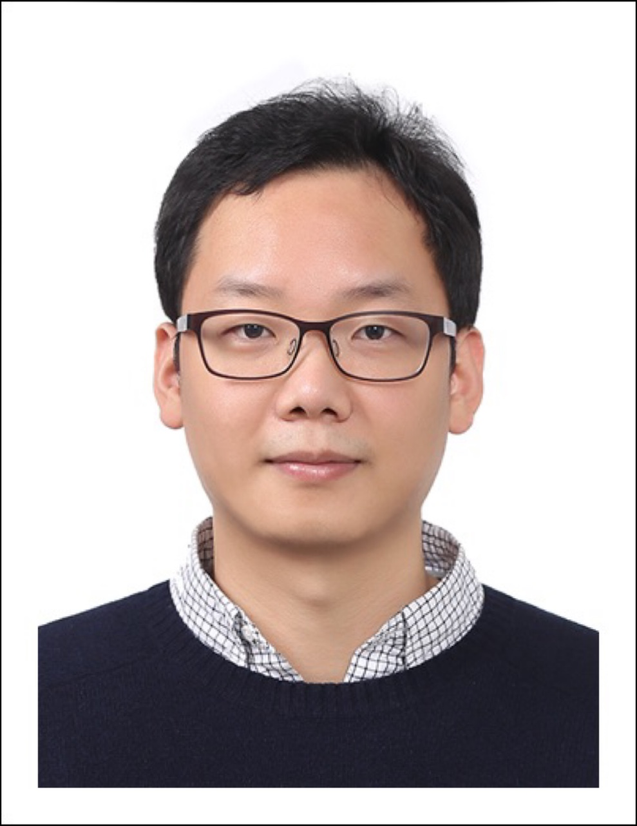
Yoochul Lee
M. 010-4500-0704 / E-mail. yoochul.lee@khu.ac.kr
Office. 031-201-3837

Education
Hanshin University | Social Policy & Politics |  | B.A | 2006.02
Hanshin University | IR | Junkee Beak | M.A | 2008.02 | Distinction
University of Sheffield | IR | John Hobson | M.A | 2014.09 | Distinction
University of Bristol | Politics | Zhang, Yongjin | Ph.D | 2020.11

PhD Thesis Tittle
The Struggle for Justice: Korea in the Historical Construction of International Order in East Asia (Supervisors: Prof. Zhang, Yongjin, Dr. Torsten, Michel)

Research Interest
Subject International Relations Theory, East Asian IR, British IPE
Macro IRT and International Norms, History of East Asia International Politics, Security (Economic Statecraft and Emerging Technology)
Micro Security Norms(LAWS, AI-AWS), Emerging Technology Security,
Just War Theory, Economic Statecraft (Export Control, Sanction, GVC, Rare Materials), East Asian Norms and International Order, ESG(Crimate Crisis and Planetary Politics), English School Theory, Peace Treaty in East Asia

Work Experience
Major Career
2025.03 ~ Now | Institute for Peace and Unification Studies, Seoul National University/ Senior Research Associate
2023.03 ~ 2025.02 | College of International Studies, Kyung Hee University / Visiting Professor
2022.07.01 ~ 2023.03.15 | International Relations Institute, Inha University / Research Professor
2023.03.01~2024.02.28 | Pacific-Asia Research Center, Institute of Global Affairs / Director
2020.04.01~2021.02.28 | Korea Society Opinion Institute / Research Fellow
2019.08.19~ 2020.12.31 | National Election Commission / Oversea Researcher

기타활동
2022.01.01~Now | Korea Association of Security and Trade / Board Member
2024.04.30~Now | Korea Diplomacy Plaza / Board Member
2022.07.01~Now | Liberal Arts Journal New Radical Review / Editorial Member
2023.03.01~ Now | Department of Political Science and International Relations, Seoul National University / Teaching Associate
2021.09.01~2024.08.31 | Department of Global Governance, Sookmyung Women’s University / Teaching Associate
2022.09.01~2023.08.31 | Department of Politic and Diplomacy, Inha University / Teaching Associate
2023.03.01~2023.08.31 | Department of Politic and Diplomacy, Sungshin Women’s University / Teaching Associate
2021.03.01~ Now | Department of International Relations, Hanshin University / Teaching Associate
2021.09.30~2022.08.31 | The Peaceful Unification Advisory Council, UK / Academic Advisor
2022.05.13~ Now | Eurasia Institute, Hanshin University / Visiting Resarch Associate

연구논문
 |  | The New Civilization, Artificial Intelligence as the Standard of the Digital Economy: Digital Ecconomy Polarization in the Global South | Oeconomia Copernicana (Scopus Q2) | 10-1 | Scopus
 |  | A Journey to Where?: Internationalization and Diugitalization of the RMB and the Belt and Road Initiative | Journal of Digital Economy(Scopus Q2) | 4-1 | Scopus
 |  | Transitional Justice, Time between War and Peace: War Crime and its Prosecutions, | Revista Espanola de Derecho Canonico (Scopus Q2) | 5-1, 15-24 | Scopus
 |  | Human Security Norms and Reconstruction of Global Governance: Meta-Governance for Human Security | South Eastern European Journal of Public Health | XXVI -S1 | Scopus
 |  | The War Without Humans: The Ethical Issues Arising from the Automation of Warfar | Machine Science Journal | 17-1, 50-56 | Scopus
 |  | Peace for Public Health Cooperation between the Cities: Epistemological Turn of Urban Diplomacy on Korean Question | South Eastern European Journal of Public Health (Scopus) | XXV-2, 367-376 | Scopus
 |  | Writing a Note on the Critical Theory of International Relations: Can Critical Theories of International Relations | International Journal of Humanities Education (Scopus) | 12-2/368-386 | Scopus
 |  | For the ‘Diligent yet Impoverished Global South’: Post-Colonial Reconstruction of Korean International Development Study | Journal of Asian Studies/  한국아시아학회 | 27-4/  2024.10.30 | KCI
 |  | Intervention, between Sovereignty and Human Rights : J. Habermas versus C. Schmitt | Korea and World Review/한국국회학회 | 6-5/  2024.9.30 | KCI
 |  | Synchronizing AI and Human Epistemology: Ethical Issues and Multi-faceted Responsibility System in the Use of AI Lethal Autonomous Weapons | 국제정치논총/  한국국제정치학회 | 64-3/  2024.9.30 | 우수  KCI
 |  | When the War Ended: Most Urgent Moral and Political Priorities for the Transition to Peace | Korea and Global Affairs/ 한국정치사회연구소 | 8-4/  2024.8.31 | KCI
 |  | A Journey Toward Non-Western International Relations Theory: Non-Western Conceptualization of English School (DOI: 10.1111/pafo.12254) | Pacific Focus / IHU Center International Studies | 39-2  /2024.8.20 | SSCI
 |  | Decolonization and Cold War Dynamics Through the Establishment of Embassies of South Korea and Indonesia | Journal of Asian Studies/  한국아시아학회 | 27-3  /2024.8.30 | KCI
 |  | Reason Why We Do Care of Future Generations: Theory of Justice in the Anthropocene | Review of Contemporary Philosophy (Scopus, Q1) | 22-1
 |  | Trigger of American Hegemony: the origin of the US Hegemony | Contemporary Readings in Law and Social Justice (Scopus Q2) | 15-2, 263-381
 |  | The Paradox of Value based Alliances : The Korean Peninsula between the Cold War and the New Cold War | Economy and Society /  비판사회학회 | 140  (314-346)  /2023.12. 1 | 우수  KCI
 |  | “Compass” without a Magnetic Needle : Outlook of EU Military Strategy without UK | Korea and Global Affairs/  한국정치사회연구소 | 7-6  (507-540)  /2023.12.30 | KCI
 |  | Epistemological Reconstruction Urban Peace Diplomacy on Korean Question | Humanity and Social Science 21/  (사)아시아문화학술원 | 14-3  (763-776)  /2023.6.30 | KCI
 |  | Epistemological Reconstruction Urban Peace Diplomacy on Korean Question | Journal of Asian Studies /  한국아시아학회 | 26-2  (177-192)  /2023.5.31 | KCI
 |  | Korean Identity, as a Middle Power in IR: International Relations Theory of Identity and its Critique | Linguistic and Philosophical Investig (Scopus Q1) | 22-2, 115-129,
 |  | Rising of Emerging Security and Evolution of China’s Economic Statecraft on Rare Earths | 동북아논총/  한국동북아학회 | 27-4  (29-56)  /2022.12.30 | KCI
 |  | Conflict between the Order and Norms in the War in Ukraine: From the Ethics of Power to Immoralismus | 국제정치논총/  한국국제정치학회 | 62-4  (7-56)  /2022.12.31 | 우수  KCI
 |  | ‘정의로운 전쟁’은 가능한가  - 러시아의 우크라이나 침공 | 기독교사상/  대한기독교서회 | 763  (31-41)  /2022.7.1 | 우수  전문  잡지
 |  | A Meta-theoretical Review and Alternative Theory of International Politics of Climate Crisis: Planetary Politics | Humanity and Social Science 21/  (사)아시아문화학술원 | 13-4  (22170-2232)  /2022.8.20 | KCI
 |  | An Alternative Conceptual Framework of International Political Economy: Focusing on Neo-Gramscianism | Humanity and Social Science 21/  (사)아시아문화학술원 | 12-3  (2315-2330)  /2021.6.30 | KCI
 |  | For Turning from Westerncentrism of International Relations Theories: Focusing on the Examination of English School Theory | Journal of International Politics/  동아시아 국제정치 학회 | 24-2  (225-260)  /2021.6.30 | KCI
 |  | The Reconstruction of Korean Question by English School of International Relations Theory, Tension between Order and Justice | Journal of Asian Studies /  한국아시아학회 | 24-2  (173-190)  2021.5.31 | KCI

주요 국내외 학회 발표 경력
단독 | The Korean Association of International Studies 2024 Summer Conference: “Ethical Issues and Dilemmas of AI Self-Destructive Weapons: Toward a Just War Theory and International Humanitarian Law.” | 2024.6.28 | Gangleung
교신  2인 | 13th Annual Symposium of the Consortium for Asian and African Studies [CAAS]:  “Toward Cosmopolitan Society in Korea: The Identity of 'Koreans+' and Korean Society” | 2023.11.9 | Tokyo
단독 | 2023 East Asia Quadrilateral Dialogue:  “Dead-end Street: Learning to Live a Nuclear DPRK in the Post-Unipolar Moment” | 2023.10.11 | Tokyo
단독 | The Korean Society of Contemporary European Studies Spring Conference:  “The EU's Global Strategy and Relations with the UK in the Post-BREXIT Era | 2023.05-12 | Seoul
단독 | KIEP 2023 Integrated Conference on Emerging Area Studies: “Complex economic security and China's economic governance: focusing on rare earth issues.” | 2022.10.21 | Yeosu
단독 | Gyeonggi International DMZ Forum:  “Tensions between Coercive Norms and the Order of Power in the Ukrainian War: From the Ethics of Domination to the Ethics of Transcendence.” | 2022.9.17 | Ilsan

출판실적
기고 | Liberalism and the New Cold War: American Liberalism Faced Realities and Non-West | 뉴래디컬리뷰 | 2022 | 도서출판b
기고 | U.S.-China Strategic Competition and Security in the New Cold War | 뉴래디컬리뷰 | 2022 | 도서출판b
편역 | Japan on the Cross Road | 교육부추천학술도서 | 2010 | 메이데이
편역 | American Minority Revolution | 교육부추천논술서적 | 2009 | 메이데이

참여연구실적
1. | Researching trends in discussions about the impact of new technologies, such as AI, on disarmament and nonproliferation. | 2023.09-11 | 외교부
2. | Researching the climate crisis and international law trends | 2022.09-11 | 국립외교원
3. | 對 日本 시민사회 및 지자체를 통한 정책공공외교  추진 방안 | 2021.06-09 | 외교부
4. | 통상분야 국민 여론수렴 및 인식조사사업 | 2020-2021 | 통상교섭본부
5. | 해외선거제도 연구 (영국) | 2018-2021 | 중앙선관위

장학금 및 포상
포상 | 강사 | 2022학년도 1학기 우수강의자상 | 2021.9-2021.12 | 한신대학교
장학금 | 박사 | Faithshare Scholarship for Merit PGR Researcher | 2015.9-2019.9 | Church of Scotland
장학금 | 석사 | Post Graduate Merit Scholarship | 2013.9-2014.11 | University of Sheffield
장학금 | 석사 | 성적우수 장학금 | 2006, 2007 | 한신대학교

강의 경력
1. | 국제정치입문 | 서울대학교 | 2023-1~ | 3학점
2. | Major Issues in Global Affairs | 경희대학교 | 2024-1 | 3학점
3. | Topics in International Relations | 경희대학교 | 2023-2 | 3학점
4. | Modern History of East Asia | 경희대학교 | 2023-2 | 3학점
5. | Introduction on International Relations | 숙명여자대학교 | 2023-1 | 3학점
6. | 동아시아 정치경제론 | 성신여자대학교 | 2023-1 | 3학점
7. | 국제정치학개론 | 인하대학교 | 2022-2  ~2023-1 | 3학점
8. | 국제학 심화 세미나 II | 숙명여자대학교 | 2022-2 | 3학점
9. | 국제학 심화 세미나 I | 숙명여자대학교 | 2022-1 | 3학점
10 | 동아시아 역사 | 숙명여자대학교 | 2021-2 | 3학점
11. | 국제정치이론과 역사 | 한신대학교 | 2021-1, 2023-1 | 3학점
12. | 국제학입문 | 한신대학교 | 2021-1, 2022-1 | 3학점
13. | 국제사회의 미래 (신기술과 안보) | 한신대학교 | 2022-1 | 3학점
14. | 국제문화와 커뮤니케이션 | 한신대학교 | 2021-2 | 3학점
15. | 글로벌사회의 이해 | 한신대학교 | 2021-2 | 3학점
16. | 현대세계정치의 이해 | 한신대학교 | 2023-2 | 3학점
17. | 한국정치론 | 이화여자대학교 | 2025-1 | 3학점
18 | Statistical Understanding and Society | 전북대학교 | 2025-1 | 3학점
19 | Advanced Seminar on Global South | 전북대학교 | 2025-1 | 3학점
20

